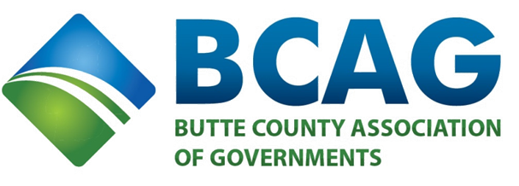

BCAG Board of Directors Meeting

September 22, 2022

9:00 a.m.

BCAG Board Room
326 Huss Drive, Suite 100
Chico, CA 95928

BCAG BOARD MEETING LIVE

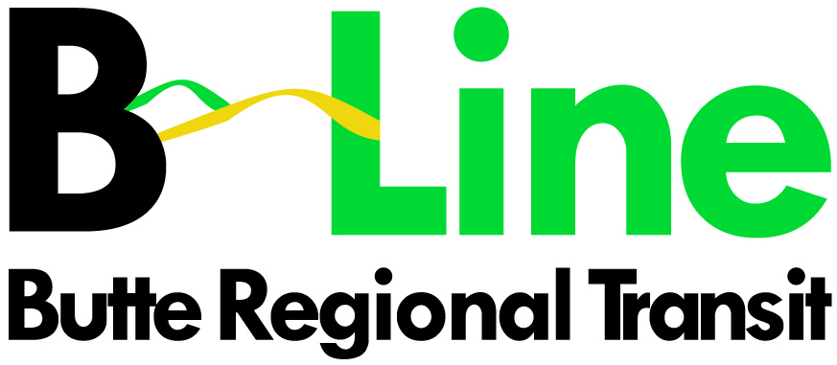

This meeting of the BCAG Board of Directors will also be available via Zoom
through the following Zoom link:

Zoom Meeting ID: 838 3657 8767 Password: 377789
To join the meeting by phone: +1 669 900 6833

Members of the public may attend the meeting in person or via Zoom, public comments may also be sent to: board@bcag.org

- Pledge of Allegiance
- Roll Call

CONSENT AGENDA
- Approval of Minutes from the August 25, 2022, BCAG Board of Directors Meeting (Attachment) – Ashley
- Approval of Capital Reserve Funds for B-Line Shelter Improvements (Attachments) - Sara

ITEMS REMOVED FROM CONSENT AGENDA – If Any

ITEMS FOR ACTION
5. Adoption of the 2023 Federal Transportation Improvement Program (FTIP) (Attachment) – Ivan

ITEMS FOR INFORMATION
- Butte Regional Transit B-Line 2021/22 Fourth Quarter Report (Attachment) – Victoria

ITEMS FROM THE FLOOR
- Members of the public may present items to the BCAG Board of Directors, but no action will be taken other than placement on a future agenda.

ADJOURNMENT
- The next meeting of the BCAG Board of Directors has been scheduled for Thursday October 27, 2022, at the BCAG Board Room & via Zoom.
Copies of staff reports or other written documentation relating to items of the business referred to
on the agenda are on file at the office of the Butte County Association of Governments (BCAG).
Persons with questions concerning agenda items may call BCAG at (530) 809-4616.

Any handouts presented by speakers are to be distributed to the
Board by the Clerk of the Board.

